**I recommend opening in word so that the equations render properly (File -> Info -> Open in desktop app)**

# Question 1 (Please check these as I’m not 100% sure)

## ai)

For table (i): The game is not potential, as the closed circuit $\left(A,D\right)→\left(A,E\right)→\left(B,E\right)→\left(B,D\right)→\left(A,D\right)$ has a sum of differences $1+2-1+4 = 6 ≠0$

For table (ii): The game is potential, one matrix $Φ\left(x\right)$ is shown below:

|  |  |  |  |
| --- | --- | --- | --- |
|  | D | E | F |
| A | 0 | 4 | 2 |
| B | 3 | -1 | 6 |
| C | -2 | 2 | 1 |

## aii)

For (i): Based on the fact that i is not a potential game, we cannot say anything about the existence of a pure Nash Equilibrium, or whether best response dynamics will converge of not

For (ii): Given that this is a potential game, we know that a pure Nash Equilibirum exists, and that best response dynamics must converge.

## aiii)

For (i): (B,D) is the only PNE

For (ii): (C,D) and (B,E) are PNE. Note that row C dominates row A, and subsequently column D dominates column F.

## bi)

A game is a congestion game if we have a set of players, a set of resources, the cost of a particular resource can be expressed as a function of solely the number of players selecting that resource $l_{r}(\left|x_{r}\right|)$, and player costs can be expressed as $J_{i}\left(x\right)= \sum_{r∈x_{i}}{l_{r}({\left|x\right|}_{r})}$.

In this case, we have a set of players $i∈\{1, …, n\}$ and a set of resources $r∈\{1, …, m\}$. Furthermore, we can express the cost function for a player on a particular resource as $l_{r}\left(\left|x_{r}\right|\right)=\frac{c_{r}}{|x_{r}|}$. The cost of player i can be expressed as $J_{i}\left(x\right)= l_{r_{i}}$. Hence G is a congestion game by the definition of a congestion game.

## bii)

G is $(n, 0)$-smooth iff $\sum_{i}{J_{i}\left(x_{i}^{'}, x_{-i}\right)≤nSC\left(x^{'}\right)=n \sum_{i}{J_{i}(x^{'})}} ∀x, x^{'}∈X$. By the definition of G, $\sum_{i}{J_{i}\left(x_{i}^{'}, x_{-i}\right)}= \sum_{i}{\sum_{r∈X^{'}}{\frac{c_{r}}{{|x_{i}^{'}, x_{-i}|}_{r}}}}$, $\sum_{i}{J_{i}(x^{'})}= \sum_{i}{\sum_{r∈X^{'}}{\frac{c_{r}}{{|x^{'}|}_{r}}}}$. It is therefore sufficient to prove that $\frac{c_{r}}{{|x_{i}^{'}, x_{-i}|}_{r}}≤n\frac{c_{r}}{{\left|x^{'}\right|}_{r}} ∀r, ∀x, x^{'}∈X$, or equivalently ${\left|x^{'}\right|}_{r}≤n{|x_{i}^{'}, x_{-i}|}_{r} ∀r, ∀x, x^{'}∈X$. To show this, let us consider the meaning of these 2 allocations. Allocation $(x_{i}^{'}, x_{-i})$ is allocation $x^{'}$ where every non- $i$ player deviates to allocation $x$. Since every player selects exactly one resource, we know that $0 ≤{\left|x\right|}_{r}≤n ∀r, ∀x∈X$. Therefore, in a worst case scenario we could have an allocation $x^{'}$ where all players are using the same resource, i.e. ${\left|x'\right|}_{r}=n$ and an allocation $x$ where all players are using different resources, i.e. ${\left|x\right|}_{r}=0$, meaning that in allocation $(x_{i}^{'}, x_{-i})$, only player $i$ remains on the original resource, i.e. ${\left|x_{i}^{'}, x_{-i}\right|}_{r}=1$. Therefore ${\left|x^{'}\right|}_{r}≤n{|x_{i}^{'}, x_{-i}|}_{r}$. Hence we have shown that G is $(n, 0)$-smooth.

## biii)

Recall that the price of anarchy for a $(λ,μ)$-smooth game is upper bounded such that $PoA ≤\frac{λ}{1-μ}$, hence for G $PoA ≤n$.

## biv)

Consider an instance of G with 2 resources and n players, where $c_{1}=n, c_{2}=1$. Clearly, the allocation which minimizes $SC(x)$ is when all players pick $r_{2}→SC\left(x_{OPT}\right)=1$. However, the worst Nash equilibrium is when all players select $r_{1}$, as the individual cost of each player $J_{i}\left(x\right)=1 ∀i$, meaning they cannot improve their cost by switching to $r_{2}$, which gives a $SC\left(x_{NASH}\right)=n$. $\frac{SC(x_{NASH})}{SC(x_{OPT})}=n$, hence the bound obtained in (biii) is tight.

# Question 2

## a)

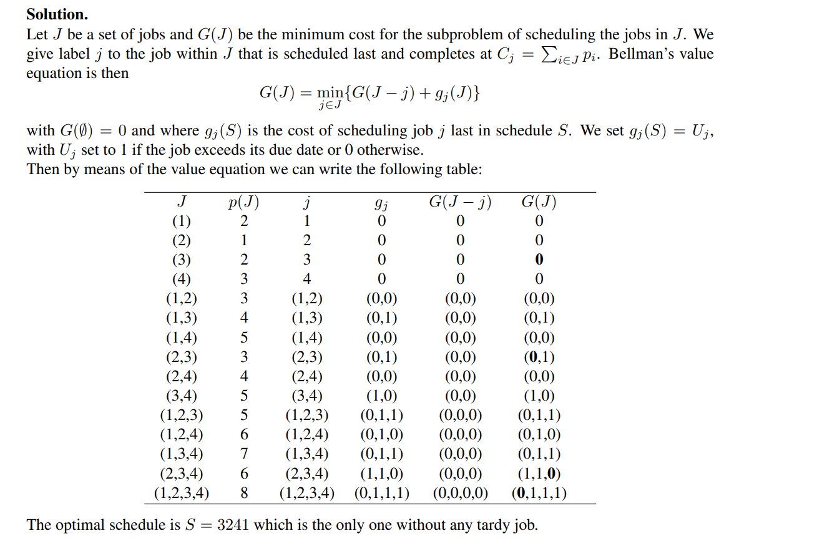

## b)

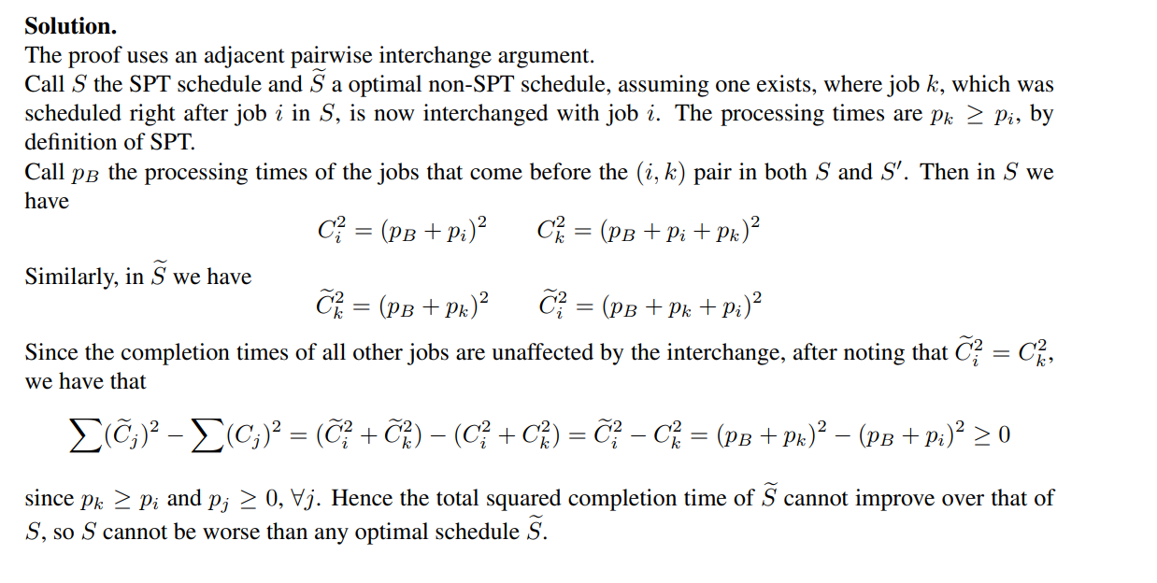

## ci)

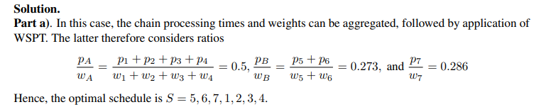

## cii)

I think this soln is wrong because the jobs are already split such that all the processing times are unit (which we only need to do in part iii). However, if you ignore jobs with index >8 then you get the correct tree.

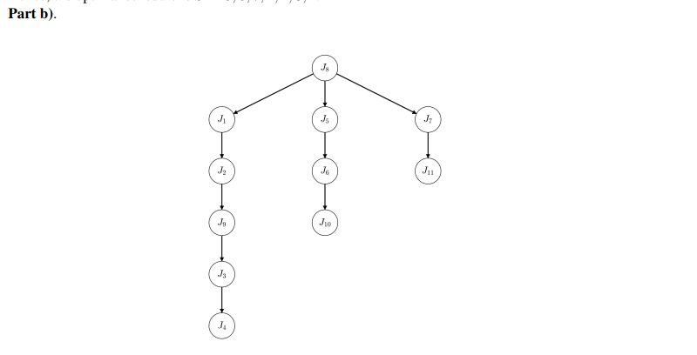

## ciii)



